**Faculty Dashboard:**

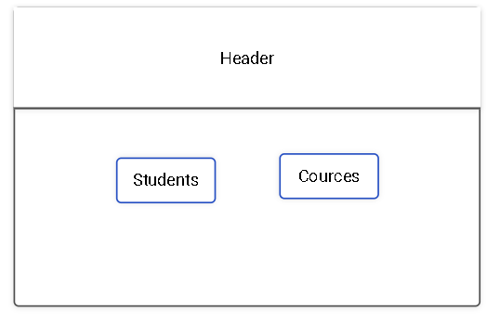

After clicking on student’s button faculty can select the yearwise-batch.

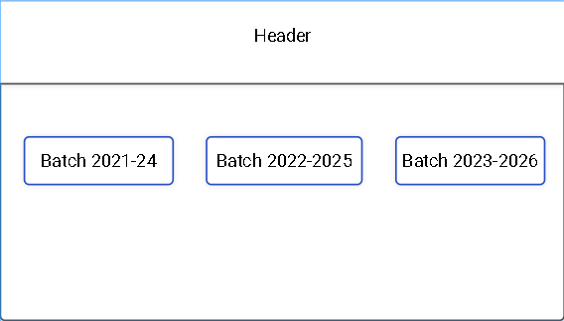

After selecting batch it will show following table

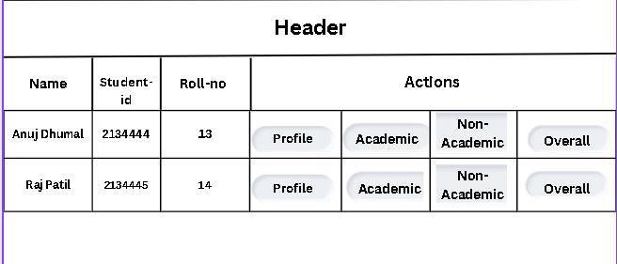

After Clicking profile it will redirect to students profile.

After Clicking Academic it will redirect to students Academic Data.

After Clicking Non-Academic it will redirect to students Non-Academic Data.

In reco following data will be seen

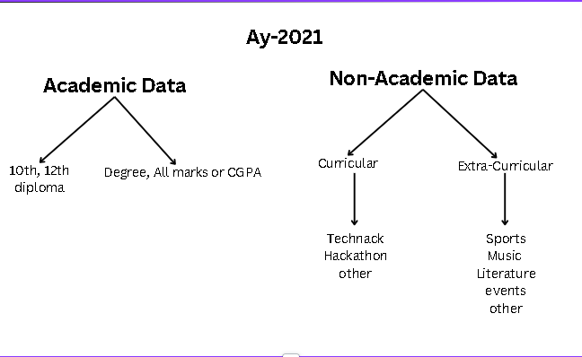

**AY-2022**